Introduction
Possibilities
#poetry #space #relations #creativity #dialogue #assertiveness
Czym jest uczenie się?
#song #czym jest uczenie się #porażka #radość uczenia się #asertywność
Who I am - bettering yourself
#sculpture #music #photography #creativity #reagowanie na bodźce #czytanie swoich emocji #assertiveness #respektowanie zmienności nastrojów #self-acceptance #communication
A walk
#photography #storytelling #storyboards #comics
Selfie
#photography #self-portraiture #selfie
Arcydzieła i ja
#painting #dance #ballet #street theatre #posters
Important moments
#storytelling #photography #comics #relacje #self-acceptance #creativity
I am important
#painting techniques #applications #painting #creating #relationships #emotions #self-discovery #colors
Express yourself
#malowanie na tkaninie #projektowanie #malarstwo
współczesne #relacje #samoświadomośc #tworzenie
About the authors

Introduction
Educational stART is a starter packet for educators containing ideas for using art as an educational tool, for the purpose of understanding the world as well as yourself.
Following the Platonic ideal that art should be the basis of education, we want to allay any anxieties surrounding its use and re-introduce it to its rightful place in school.
Through this publication, we want to invite you to create this change with us. Together, our work will be more visible!
Thank you to Marta Florkiewicz-Borkowska (the main mentor of Educational stART), Joanna Waszkowska and Kami Śliwowski for their substantive care, as well as to Weronika Skaczkowska for her graphic design.
These materials have been created as part of the Open Culture Studio, organised and created by Centrum Cyfrowe.
Natalia Bielawska
Katarzyna Lewandowska - Staroń
Ada Słowik

Materials available through Creative Commons licenses.

Natalia Bielawska

Possibilities
An idea for the first lesson to start out the school year

#poetry #space #relations #creativity #dialogue #assertiveness
Times: 45 minutes
Necessary supplies:
- pages with quotes from Wisława Szymborska’s poem Możliwości:
http://www.szymborska.org.pl/mozliwosci.html;
- a large flipchart, colourful markers.
Activity description
- Participants sit in a circle. The lesson can take place in any space (not necessarily a classroom).
- The activity leader passes out pages with fragments from Wisława Szymborska’s Możliwości. The leader does not inform the participants what is on the pages.
Attention: when passing out the pages, maintain the correct order of the poem.
- The teacher asks that each person in the circle introduces themselves and reads their quote.
- Each page summons different emotions: O, trafiła pani, faktycznie wolę koty!, Nie powiem tego, nienawidzę zielonego itp.
- After each page is read out, the teacher informs participants that they just completed reading Wisława Szymborka’s poem Możliwości. Eventually (if there are fewer participants than verses), everyone reads to the end of the poem.
- The leader asks if the lines on their cards correspond to the students’ interests/opinions. The leader asks everyone to write down what they actually prefer. On one page, 3 pieces of information about yourself, on the second, 3 pieces of information about expectations regarding learning methods at the start of the school year.
- The students share their needs together and introduce themselves. They select one expectation or #preference, and write it on an A1 piece of paper, ex. #i prefer group assignments #i prefer field trips #i prefer no yelling.

Reflections
Lessons are a space created by teachers and students. They are a space of shared effort. The teacher creates a dialogue. They are not the only one who speaks and knows what is best for a student; they must also listen and teach how to listen.

Natalia Bielawska

What is self-learning?
Failure is an integral part of learning

#song #what is self-learning #failure #joy of learning #assertiveness
Time: 45 minutes
Necessary supplies:
- equipment for playing music;
- Marek Grechuta’s song Wędrówka:https://youtu.be/1IqzNPAv0mk;
- printed copies of the song’s lyrics (for each participant): http://bit.ly/322lmlD;
- flipchart pages;
- colourful markers.
Activity description
- We ask the students to find a comfortable place for themselves (they can lie on the floor, sit on a chair, pick a corner of the room).
- We introduce relaxation exercises: close your eyes, feel that by closing your eyes you move to another space where you feel extremely well (maybe you are in a forest, maybe by the sea, maybe in your own bed), take a deep breath in and out, feel your body, and say: now I relax. In a moment you will hear a song. Feel it flowing into your body through your ears. Notice how you react to the melody? What do you see when you hear specific words? Maybe something upsets you? Maybe you get curious? Maybe you feel a surge of energy or anxiety? Try, whilst listening to the song, to hear your body.
- The teacher begins the song.
- After listening to the song, students share their emotions. What did I feel? How did the music affect me? How did I react to the words?
- The activity leader hands out sheets of paper with the printed lyrics of the song and asks what the lyrics are about.
- Students write down their ideas on the paper in the forms of individual words, e.g. failure, life, success, etc.
- The teacher compares the words written by the students with prepared proposals and asks them to match particular words with appropriate quotations from the song, e.g. failure, defeat (you will not reach the seashore, what will be the seashore of this wandering), success, popularity (you will be a desire for earth, and a signpost for missiles), progress (the way from thoughts to machines), empathy (when you enter the forest you become a tree), emotions (when your heart rumbles like a bridge), action, work (the anxiety of furrows you give to fields).
- The teacher asks why a song about anticipated failure has such a cheerful melody. He or she writes down pupils' ideas on the board.
- Summary: The titular wandering is a metaphor for life – and life is constant learning, new challenges, new paths. We feel that there is no difference between learning and living. Setbacks (broken bridges), obstacles (missing the boat) are natural, though not pleasant, they are an essential part of the journey. If you really learn, your world expands, not shrinks. There is no end to the journey: you pose new questions, answers appear, which generate further questions.

Reflections
Failure is something natural, though it’s not neutral. This is why we don’t like making mistakes – they bring up unpleasant emotions.

Ada Słowik, Natalia Bielawska, Katarzyna Lewandowska - Staroń

Who I am – bettering yourself
Perceiving yourself in relation to your mood

#sculpture #music #photography #creativity #reacting to impulses #reading your own emotions #assertiveness #respecting mood changes #self-acceptance #communication
Times: 45 minutes
Necessary supplies:
- speakers;
- computer or phone with access to the necessary songs;
- music: Michał Lorenc’s Bandyta and Beethoven’s Moonlight Sonata;
- modelling clay.
Activity description
- The lesson takes place in the green space around the school.
- Students propose two pieces of music (without lyrics) that contrast one another: happy – sad, energetic – relaxing e.g. Michał Lorenc’s Bandyta (http://bit.ly/2XMRqLa) and Beethoven Moonlight Sonata (http://bit.ly/2YoccxB).
- Students create a clay version of themselves for 10 minutes whilst listening to the first piece. It doesn't have to be a character, it can be a symbol.
- During the second piece of music they create a second version of themselves (10 minutes). This can also be a symbolic representation of themselves.
- Willing students present their works, highlighting the differences and similarities.
- The teacher sums up the pupils' reflections – our perception of ourselves can be different depending on the mood we are in. Awareness of the influence of music on our mood.
- Pupils place the figures together and take a group photo of them.

Reflections
Not only does everyone see us differently, we perceive ourselves differently depending on the day, our mood and external stimuli. The passage of time also changes us – hence the recommendation to hold the workshop twice: in September and June of the school year or in grade 4 and again in grade 8 at the end of the education cycle.
We are shaping ourselves throughout our lives...

Ada Słowik

A walk
Creative endeavours trigger emotions

#photography #storytelling #storyboard #comics
Time: 2 x 45 minutes
Necessary supplies:
- smartphones;
- Pixlr application https://bit.ly/2K58CnI and Mentimeter https://bit.ly/2HVi4qZ;
- blank A4 paper;
- pencils.
Description of activities for the first and second lesson
Lesson 1 - outside the classroom.
- Students take photos entitled My place in school.
- They present their photos
- They name the feelings associated with the space. Students can utilise the application Mentimeter to help with this https://bit.ly/2HVi4qZ.
- In groups, they write a short, emotional story about their chosen place.
Lesson two - outside of school.
- Participants replace the text of the story with pictures, taking 4 or 5 photos to illustrate the content of their story. They then create a comic strip from the photos https://bit.ly/2K58CnI.
- Outside, they pair up with someone from a different group and sit with their backs to each other.
- One student describes their comic, which his or her partner cannot see.
- The students’ task is to collaborate in such a manner that the other student draws a storyboard that accurately reflects the content of the original.
- We create an exhibition of the resulting drawings and compare them with the originals. Students reflect and draw conclusions.

Reflections
The activities serve to improve awareness, the ability to name emotions and to identify them with spaces in the schools, as well as to strengthen interpersonal communication.

Ada Słowik

Selfie
Face to face with emotions

#photography #self-portrait #selfie
Time: 45 minutes
Necessary supplies:
- smartphones;
- Mentimeter application https://bit.ly/2HVi4qZ;
- collection of self-portraits https://images.app.goo.gl/FVnY7P5h5G1Gk5mA9;
- http://bit.ly/2FVUOt1 http://bit.ly/2KPcHxk;
- https://images.app.goo.gl/Ls5Roo5tTXVNnmay8.

Activity description
- Students depict their own emotional states with three different selfies (version 1).
- They edit the photos – they can add text, quotes, name the depicted emotions (version 2).
- Whilst each student presents version 1, the group names/guesses the corresponding emotions (the Mentimeter app can be used for this).
- Students present their photos with text (version 2).
- Discussion. Conclusions.
- The teacher presents the self-portraits of master artists.

Reflections
The selfie is not a 21st century invention. In past eras, self-portraits were an art form of self-expression. They served painters just as the selfie does today.
Let us remember that portraiture was available amongst the elite, whilst now photography has mass appeal.

Ada Słowik

Masterpieces and me
In search of strengths

#painting #dance #ballet #street theatre #posters
Time: 45 minutes
Necessary supplies:
- smartphones;
- set of pairs: image – film (links below);
- WallaMe application: http://walla.me/.
Activity description
- The teacher shows two (or three, depending on the time) different images with a film matched to them. Before each screening, he or she asks the group to do a short introductory exercise:
- Set I
Scene titled Tego nie wypada:
Renoir, The Umbrellas https://images.app.goo.gl/qx84rnKHTxFpLmTWA
Film Girls be brave https://www.youtube.com/watch?v=3mcqUPELHGU.
- Set II
Scene titled Zatańcz, siedząc na krześle
Henri de Toulouse Lautrec, The Dance http://bit.ly/2LuQ8xM,
How to dance without legs https://youtu.be/mLe9ZSwU4aQ
- Set III
Scene titled Taśma produkcyjna
Andy Warhol, Campbell’s Soup Cans https://images.app.goo.gl/5Te2JTT1EVo4sxfP9,
KTO Theatre Peregrinus https://youtu.be/duHfT7lzhHo.
- Each time the set pairs are demonstrated, the teacher asks the same questions: What do you see? Why were these cultural texts put together? How do they relate to each other and to you and the exercise?
- During each set, students individually or in pairs write down their answers (can be loose slogans). They then virtually (using WallaMe) place them on the photographs of the images used in each of the projections.
- Summary: Participants present their reflections, reading them in a virtual exhibition accessible through the WallaMe app.

Reflections
The exercise is an opportunity to raise the issues of the sense of stereotypical expectations and imposed social roles (set I), realising oneself against limitations, searching for one's strengths in all circumstances (set II), the courage to be oneself against the majority, individualism in the face of the crowd, the rat race (set III), the interplay of different fields of art and the themes of social campaigns.

Katarzyna Lewandowska - Staroń

Important moments
I have the right to express my feelings

#storytelling #photography #comics #relationships #self-acceptance #creativity
Time: 45 minutes or 2 x 45 minutes for larger groups
Necessary supplies:
- items brought by students;
- flipcharts (one per group);
- colourful markers, crayons, etc.;
- tables, space to work in groups.
Activity description
- The lesson takes place anywhere.
- Each student brings one object important to them (the teacher explains to students in advance what they have to prepare for the lesson. Important objects for them, which they are ready to show to their classmates).
- The teacher prepares a place where students can display the objects they have brought.
- All students present their objects and the teacher gives them time to look at the objects and have a short exchange of opinions.
- Willing students about their objects and their histories. They describe the characters and situations connected to the objects, as well as the memories they invoke.
- Safety-valve institution: the teacher explains and discusses with the pupils the emotions, feelings and thoughts that the objects have evoked in them. It is worth emphasising that all feelings and emotions are important and we have the right to feel them.
- The leader divides the class into groups (each group consists of 5 to 9 people).
- In groups, pupils make up stories or comics inspired by the objects they brought with them and give them titles.
- At the end of the activity the groups present their stories inspired by the objects to the other pupils. They talk about emotions and impressions they had whilst creating them. They recognise the non-material character of things.

Reflections
Expressing and naming emotions is an important part of self-acceptance and building valuable relationships. The lesson gives students the opportunity to show their true selves.

Katarzyna Lewandowska - Staroń

I am important
Self-awareness and self-acceptance as factors of development

#painting techniques #applications #painting #creating #relationships #emotions #self-discovery #colours
Time: 2 x 45 minutes
Necessary supplies:
- space (it is advisable that the lesson takes place outdoors);
- canvas or painting material;
- paints of different colours;
- paintbrushes;
- aprons or protective clothing;
- presentation: painting techniques: http://scholaris.pl/zasob/57970;
- smartphones with application: http://walla.me/.
Activity description
- Prior to the lesson (using the WallaMe application) the teacher posts pictures presenting examples of different painting techniques and paintings made with these techniques in the area where the lesson will take place (playground, park, school): http://scholaris.pl/resources/zip-resource/id/71329.
Next they prepare the canvas or painting material in a large area so there is enough space for each student to work.
- Students should already be familiar with the WallaMe application (simple to install and very easy to use, 4th graders mastered its functions very quickly).
- Students are introduced to different painting techniques (chosen by the teacher) during the lesson. You can use a presentation from Scholaris.pl or a presentation prepared by interested students.
- Go outside with the class. Students use WallaMe to find pictures of different painting techniques and paintings.
- Then, inspired by these works, they paint pictures of their characters, reflecting their emotions of the day.
- The teacher asks students questions about their emotions during the creative process: why they used such a technique and not another, what interested them in the technique (the role of texture, colours, shapes or emotions). Each member of the class must have time to speak.
- At the end, the class (and teacher) takes a group photo with their paintings.
- The picture (preferably enlarged) is put up in the classroom. I know from experience that students like to autograph their picture, are proud of their work and are happy to tell other students and teachers about it.
Refleksja
The role of art and creation in the process of self-acceptance and relationship building. Intuitive reception of art, opening to it as an inspiration for self-expression, development and an introduction to creation.
Katarzyna Lewandowska - Staroń

Express yourself
Humans as multi-dimensional beings

#painting on canvas #design #contemporary painting #relationships #self-awareness #creating
Time: 2 x 45 minutes
Necessary supplies:
- cotton T-shirts (one per student)
- paints and markers for painting on textiles,
- sponges, paintbrushes,
- paper T-shirt models for designing,
- iron,
- instructions for how to paint on fabric, e.g.: www.youtube.com/watch?v=Ja5M8pN8ASc.
- trends in 20th century painting to inspire students, e.g.: https://www.youtube.com/watch?v=Y_V4wkPxCr0,
- albums, illustrations of paintings (as varied as possible).
Activity description
- The teacher invites students to a sharing circle: each students answers questions about his or her favourite books, films, colours, literary or film characters, interests, paintings, etc.
- The leader presents a lecture on contemporary painting, giving students the opportunity to express their feelings, emotions and impressions after having seen the material.
- Students use the paper forms to create images that reflect their personality, interests, favorite colours, works of art, characters, symbols, etc.
- The teacher presents techniques and best practices for painting on fabric.
- Students create their own T-shirts.
- Students present their T-shirts, willing students discuss their work. It’s important that everyone has the opportunity to speak and present what inspired them as well as how they expressed themselves.
- Take a group photograph of everyone wearing their shirts. It’s worth placing the photo in the classroom, where students can sign their names, which is a positive experience for them and helps them identify with their work.

Reflections
Art and creative activities allow you to express yourself and your emotions in a safe way. Man is an individual, unique and creative being.

About the authors
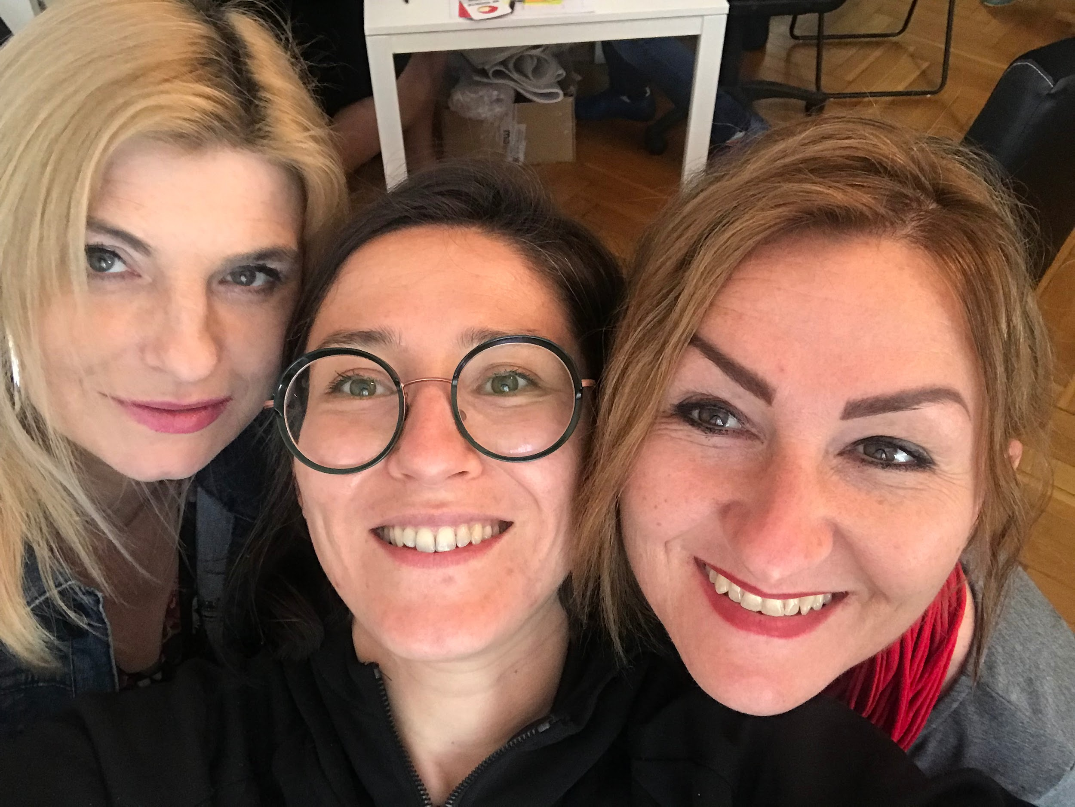
Katarzyna Lewandowska-Staroń
certified teacher of Polish, German, history and pedagogical therapy. Expert in professional promotion, OKE examiner, support expert, author of pedagogical innovation: Co kraj, to obyczaj (Every Country, Every Custom). Propagator of the theory of constraints. Creator of a website dedicated to education: @OkiemBelfra.
In teaching, I focus on relationships, mutual motivation (my students are my inspiration) and developing key competences.
Natalia Bielawska
Polish language teacher at Bednarska Elementary School in Raszyńska Territory, ambassador of #wiosna edukacji, blog author dedicated to education topics: https://622pomysly.wordpress.com/, https://konstantynopolitanczykiewiczowna.wordpress.com/.
My unsurpassed teacher role models are Ambroży Kleks and Gandalf. I like learning and I hope it will stay that way for the rest of my life.
Ada Słowik
teacher at Primary School Nr 2 in Myślenice, creator of projects including O!SWOJE!ni w przestrzeni (Bardzo Młoda Kultura Narodowego Centrum Kultury programme), EuroArTeam - jak ugryźć obraz? (in collaboration with the Academy of Fine Arts in Kraków) and Świat zamknął oczy (with the Light for Syria foundation).
I do not hesitate to be an educator after hours, making a connection that goes beyond the school. I believe in the supportive power of mindfulness and empathy.

